

Department of

Electrical & Electronics Engineering

**Abdullah Gül University**

**Homework 4**

**EE3005 Biomedical System Design Capsule**

**Submitted on: 4/21/2025**

**Submitted by: Abdullah Rihawi**

**Abdul Malik**

**Introduction**

Medical image processing enables essential advances in clinical data evaluation and diagnosis and treatment assessment along with clinical research requirements. The two essential methods within this field include template matching that identifies objects and frequency domain filtering which improves image quality. The project implements these methods to analyze different body part grayscale MRI images. Template matching determines the position of distinct anatomical features in images then frequency-based filtering (by means of Discrete Fourier Transform) enhances or reduces noise through controlling image frequencies.

1. **Template Matching Operations:**

Step 1: Image Acquisition

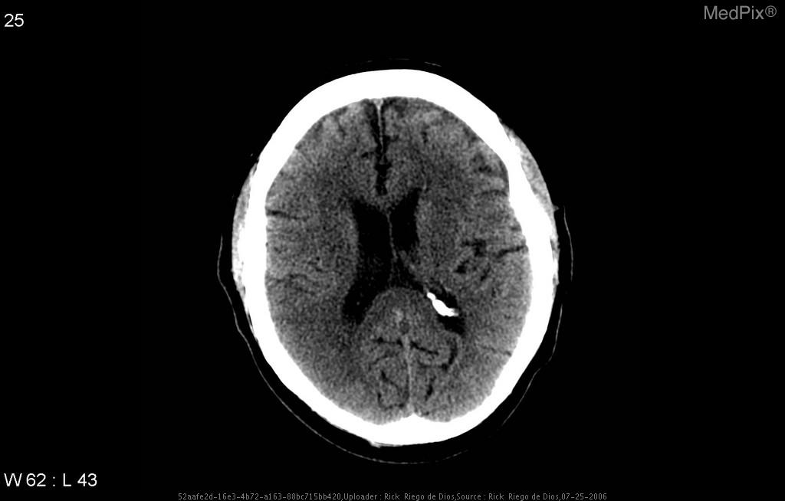The analysis used two main grayscale brain images named Image1.jpg and Image2.jpg which included their matching templates Template1.jpg and Template2.jpg. The templates show little areas of interest in separate brain scans.

Figure 4 Template2.jpg

Figure 3 Template1.jpg

Figure2 Image2.jpg

Figure Image1.jpg

Step 2: Preprocessing

The processing consistency required the conversion of RGB images into grayscale through rgb2gray. All images need standardization through this method to prepare for correlation analysis.

Step 3: The normalized cross-correlation method serves to execute template matching

The template matching operation utilized normxcorr2 function to determine normalized cross-correlation values between the template and main image. The technique helps detect identical structures between the main image and the template.

The process produced correlation maps according to the following method for each match between template images and main images.

Step 4: Locating the Best Match

The highest position in the correlation map defines exactly where the template would appear in relation to the main image. An offset was used to position this peak at the top-left corner of the template.

Step 5: Visualization of Results

A colored rectangle with red for Image1 and green for Image2 was applied to visualise the template match positioning through the original image by using the rectangle function.

Step 6: Output

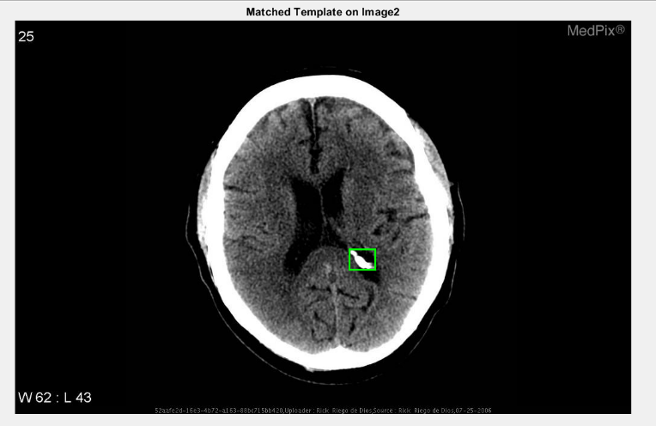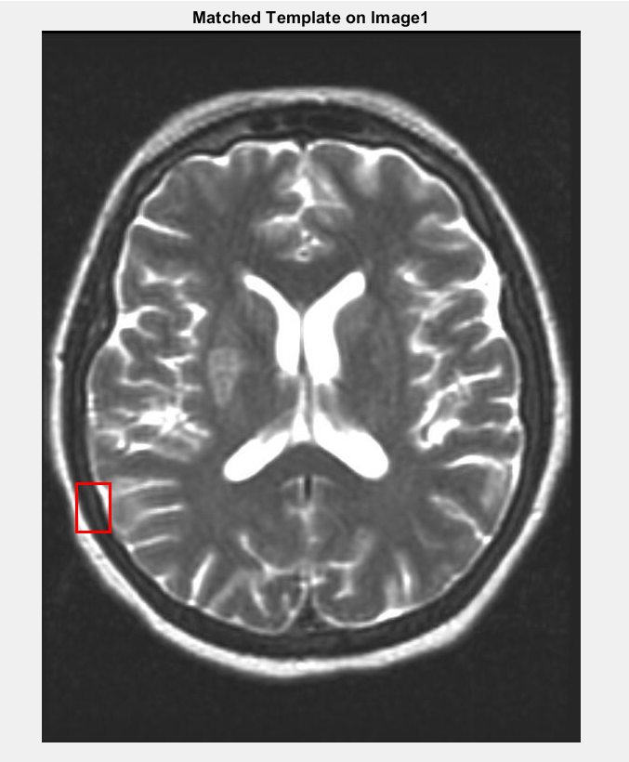The program displayed match coordinates in the console for users to verify against visual generated figures.

Figure 6 Matched template on Image2

Figure 5 Matched template on Image1

The template matching analysis finished on the two brain images as shown in Figures 5 and 6 with the template matches marked by red rectangles (Image1) and green rectangles (Image2). In both figures the best template match location appears through a red rectangle in Image1 and a green rectangle in Image2.

The normxcorr2 function located the template match across both brain images at different coordinates which included:

Image1: (38, 488) and Image2: (556, 381)

The coordinates identify the left upper corner position where the detected template found matches every full image. The images matched regions demonstrate good visual correspondence with original template figures which means the normxcorr2 function successfully located relevant areas.

A precise match area in Image1 exists at the lower-left part of brain visual data that corresponds exactly with the reference template input. The second image displays a match located in the central area near the ventricular region thus corresponding to natural features of the template.

Normalized cross-correlation produced reliable analytical results since it accurately matched structures regardless of image intensity differences and contrast variations. The method gives imperfect results in programming scenarios having these characteristics:

* The criterion of low contrast between the template signature and its surrounding areas affects the success of matching.
* Significant rotation or scaling differences.
* Presence of noise or artifacts in the images.

The results confirm template matching as an effective method for medical image-based anatomical feature localization specifically when alignment and intensity normalization procedures are applied.

1. **DFT Operations:**

Discrete Fourier Transform (DFT) was utilized during this work to implement ideal low-pass and high-pass filtering on grayscale MRI images that included an ankle view (Image 3) and brain structure (Image 4). This experimental objective proved the effects of frequency components on the characteristics of edges alongside smooth regions within images. Three significant filtration radius values 10, 30 and 60 were used in the filtering process.

Step 1: Preprocessing

The digital images underwent two preliminary steps before processing began. grayscale conversion followed normalization into double-precision floating-point values.

Step 2: Filter Design

The program used an ideal filter function to produce masks for low-pass or high-pass filtering with a specified radius. An ideal filter function generated circular low-pass or high-pass masks in the frequency domain based on a given radius.

Step 3: Filtering in Frequency Domain

The following method sequence operated at each radius:

* A 2D DFT operation must be computed on the image.
* Use the ideal filter mask for low-pass and high-pass operations.
* An application of inverse DFT processing on the results will yield the filtered image.

Step 4: Visualization

The results displayed through MATLAB’s subplot layout enabled comparison between original and low-pass and high-pass filtered image outputs at various radii:

Figure 7 Results for different radii

Ideal low-pass and high-pass filters with radii 10, 30 and 60 produce visual outputs on MRI images.

* A low-pass filter processing performs frequency component removal that produces image blurring results. When r equals 10 the image contains minimal fine details because general shapes become the primary visible elements. The filtering operation preserves additional mid-frequency details when the radius value rises to 30 or 60 and subsequently lessens the amount of blurring.
* The application of high-pass filters reveals edges and fine details because it removes low-frequency information. The filtering process with r = 10 brings out edge features with clarity yet the application of r = 60 causes structural noise and high-frequency textures to emerge primarily in the brain MRI scan.

Expanding the radius improves the cutoff threshold enabling more signal frequencies to transmit. Noise reduction functions combined with spatial smoothing come from low-pass filters yet high-pass filters enhance tissue boundaries to improve both segmentation algorithms and feature extraction methods.